**Sybase PowerDesigner**

**Physical Data Model Report**

***Model: PERM db***

***Report: Report 2***



Author: Povilas

Version:

Date: 2016-02-15

Summary:

**Table of Contents**

I PERM database diagram 3

II List of tables 3

II.1 Table USER 3

II.1.1 List of columns of the table USER 3

# PERM database diagram

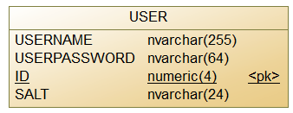

# List of tables

|  |  |
| --- | --- |
| *Name* | *Description* |
| User | Stores user as well as user authentication data |

## Table USER

### List of columns of the table USER

|  |  |  |  |  |  |  |  |  |
| --- | --- | --- | --- | --- | --- | --- | --- | --- |
| Name | Domain | Size | Unique | PK | FK | Index | Null? | Short description |
| userName | nvarchar | 255 | true |  |  |  | no | User name is user e-mail address. |
| userPassword | nvarchar | 64 |  |  |  |  | no | Stores user password as SHA256 hashed string. |
| Salt | nvarchar | 24 | true |  |  |  | no | Random number generated by CSPRNG and added to the user password. |
| ID | numeric | 4 | true | yes |  | yes | no | User identification. |